Name: Kevin Nunez student: 00323217 Linux Administration Update and Installs of CentOs and Ubuntu Adrianna Holden-Gouveia Date: 10/03/2026
In this case we are going to install and update some programs on our servers; CentOS and Ubuntu.
We need to know the (yum) term, this allows us to update and modify. That allows users to update and remove software packages.
1. Before installing any software into our system, is very important to become a root user, for this I run the command sudo -i first.
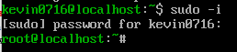
Is very important to put your password here.
2. sudo yum update: Now we are going to update our system in administrator mode, that is why the first step is important.
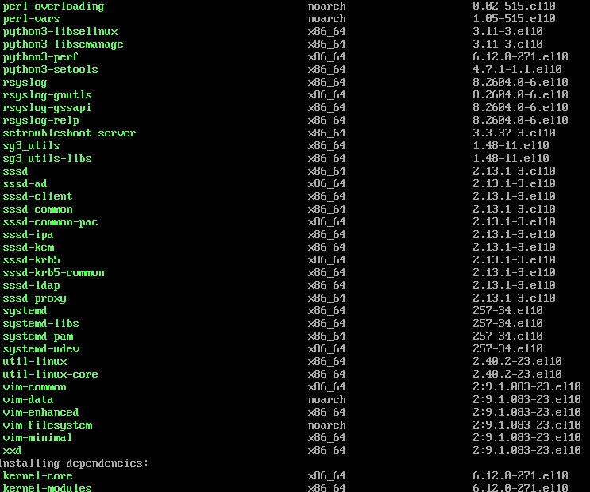
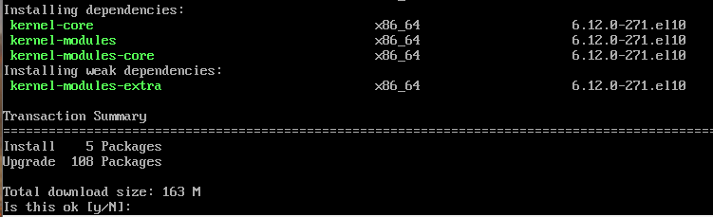
Here in this step, we need to put the letter “y” , this mean we say “yes” to this question, and we going to update the system.
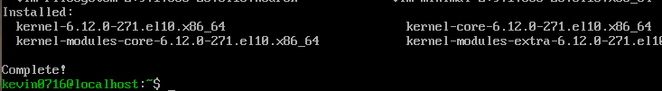
Once this is done, we can move to the next step.

Install Tmux
If you wonder what is Tmux? Tmux is an open-source terminal multiplexer for Unix-like other operating systems.
The command to install Tmux is sudo yum install tmux
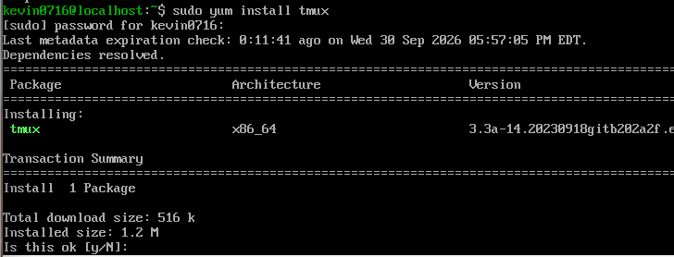
Here we type “y” for download the package.
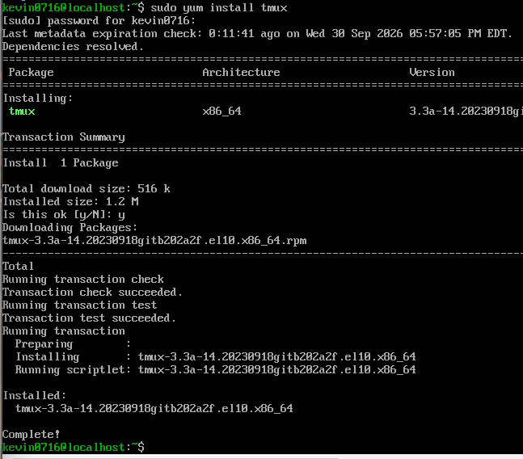
Now Tmux is complete install in the server.

Installing emacs
Emacs: when we open a file with emacs, you can just start typing and issue commands at the same time, command functions in emacs usually involve two or three keys.
The command to install emacs is sudo yum install emacs
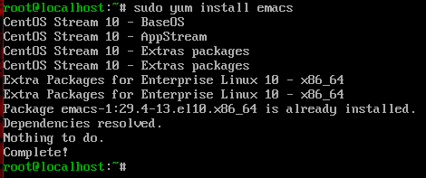
In my case is already installed and I can just use it.

Installing Fail2ban
In this case Fail2ban is not available in the CentOS package and for this reason we need to start Epel first.
EPEL: is an extra package for Linux enterprise, and this option was created by Fedora Community project for the purpose of other distribution of Linux has access to package that was not available on the default operating system package.
The command to install EPEL is yum install epel-release.
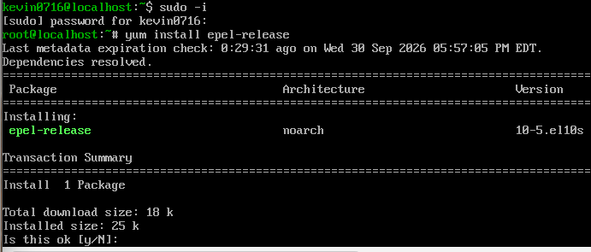
Now we type “y” to approve the installation.
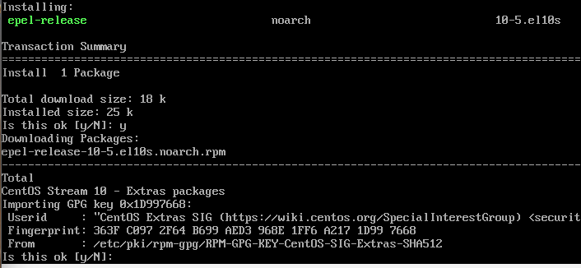
Now type “y” again. And after this we are going to see a message that our program is complete.
If you wonder, what is fail2ban?.
Fail2Ban is a type of prevention software framework that protects our computer server from brute-force attacks.
The command to install fail2ban is sudo yum install fail2ban fail2ban-systemd.
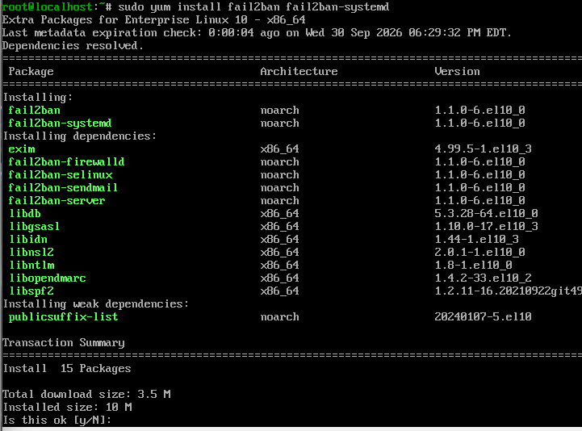
Now we type “y” here to download and after install the fail2ban.
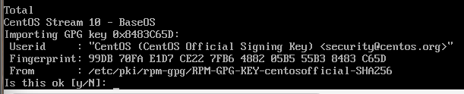
Here we type “y” again for complete the installation.
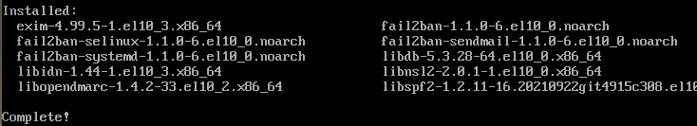
Now the fail2ban is complete and done.

Installing Cowsay
What is cowsay? Is a program that generates ASCII art pictures of a cow with a message.
The command for this is sudo yum install cowsay.
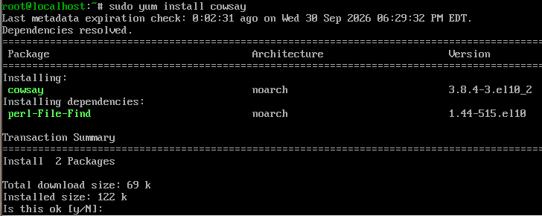
Now here we type “y” for install the packages.
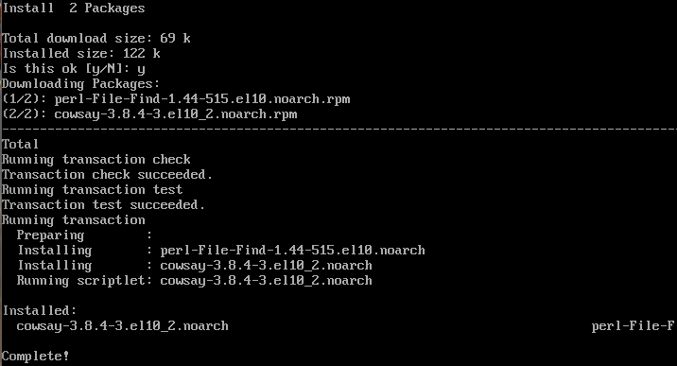
Cowsay is now completely installed on the server.

Installing Lolcat
Something important is the package for “lolcat” is named in different using the yum command is “ruby”.
Lolcat: is a utility for Linux, BSD and OSX which concatenates like cat command and adds rainbow coloring to it.
The command is sudo yum install ruby.
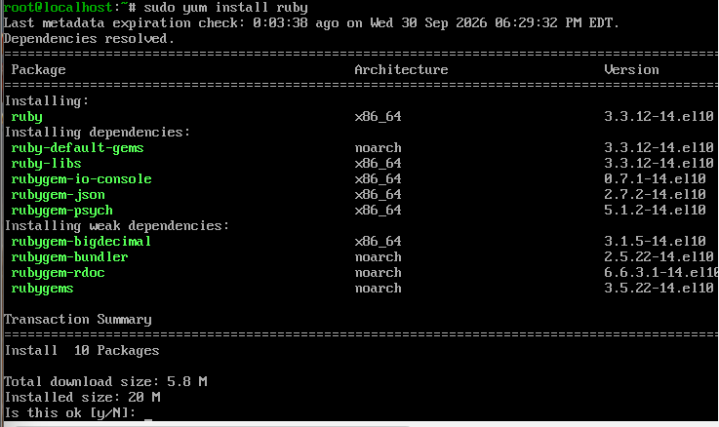
Here we type “y” for the installation.
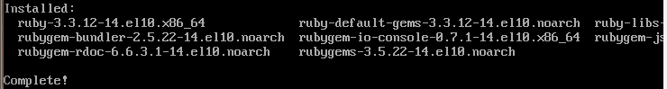
Now this program is complete.

Updating Vi to Vim
Vim: as we know VI is the standard text editor used in Linux, Vim in this case is a new version that includes visual mode, mouse support and new editing commands.
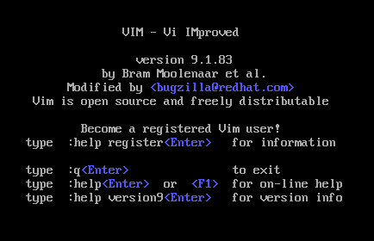
As you can see Vim is already installed on my server. If your server is not installed yet, run the command sudo yum install vim-enhanced -y
Now we want to check the files that we been installing with yum, the command is rpm -ql “filename”
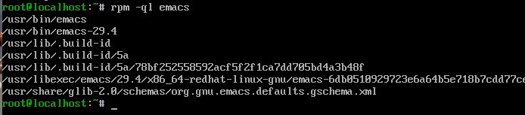
This is for EMACS and check.
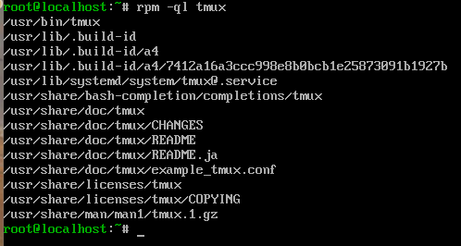
This is for check TMUX.
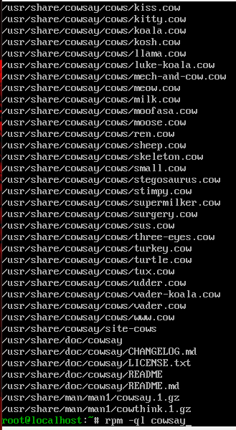
This is to check the cowsay.
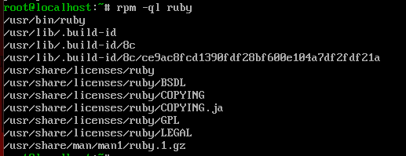
This is for check lolcat”ruby”.

Yum updateinfo “filename”: it shows the last time the package was updated in the server.
Important information just in case you need to check the repos, the command is dnf repository-packages epel list, the command list all the repos from epel.
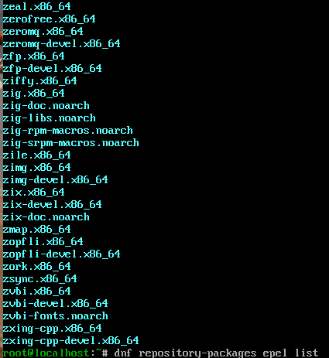

If you want to check all you install with the yum as well, the command is sudo yum list installed
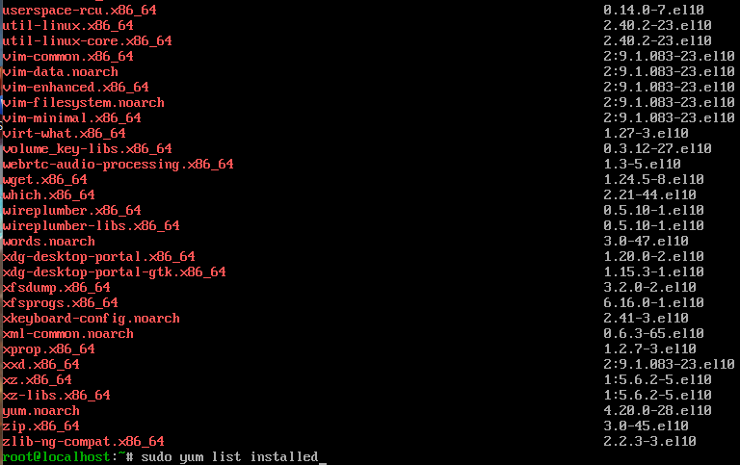
Also, can help the repo list, the command is yum repo list
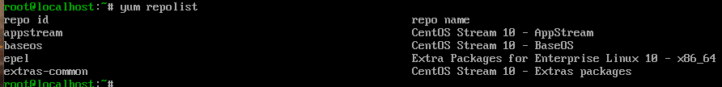

Using the packages that we download in our server CentOs
For using the Tmux tool we need to put in our terminal tmux, after this we press CTRL and B at the same time, after this you can press doble quotes (“) for the window horizontal, and % for the window vertical.
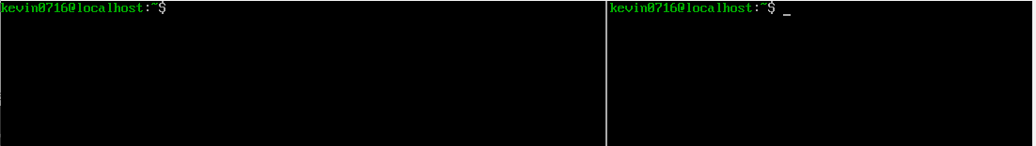
Now with Vim we run the command vim check_fail2ban.rb
Now we press “I” for insert the lines, we going to run a script that simulates tries of failed access blocked with Fail2Ban.
#script in Ruby for simulate a lecture of logs Fail2Ban
Banned_ips = [“192.168.1.50”, “203.0.113.5”, “198.51.100.12”]
Puts “==Warning of security of CentOs==”
Puts “Fail2Ban has detected and blocked the next malicious access:”
Banned_ips.each do |ip|
Puts “->Ip permanently blocked: #{ip}”
End
Now with emacs we going to add a text line on this file, the command for this is emacs -nw check_fail2ban.rb. in the final of the code with the arrows move to the last line and add.
Puts “The server CentOs is actually protected”
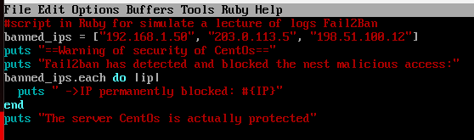
For save and exit the emacs, press the next sequence, CTRL + X, CTRL + S, CTRL + X, and last CTRL + C.
Now on the other panel that we create with Tmux we run our Ruby script, but we going to make Cowsay say the information and with the Lolcat print in colors.
Ruby check_fail2ban.rb | cowsay | gem exec lolcat
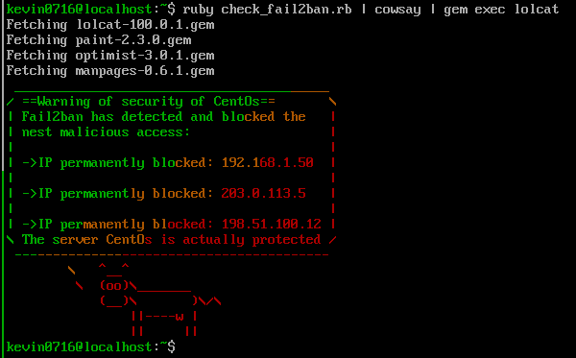

Ubuntu Update and installation
The first step is updating the packages onto the server.
Apt: advance packing tool, is a command that helps to install, update, and remove packages in Ubuntu and Debian Linux distribution.
The command for the first update is sudo apt-get update, and now we type our password.
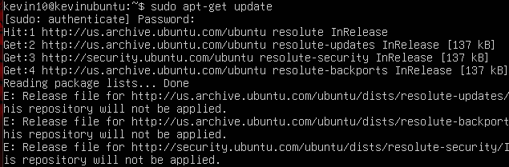
Now the system is update.

Installing Tmux in the server
If you wonder what is Tmux? Tmux is an open-source terminal multiplexer for Unix-like other operating systems.
The command for this is sudo apt install tmux.
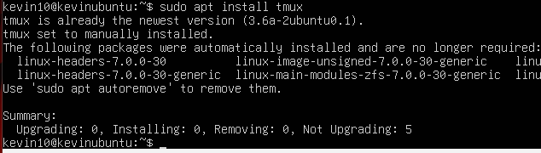

Installing EMACS.
Emacs: when we open a file with emacs, you can just start typing and issue commands at the same time command functions in emacs usually involve two or three keys. The command for install emacs is sudo apt install emacs.
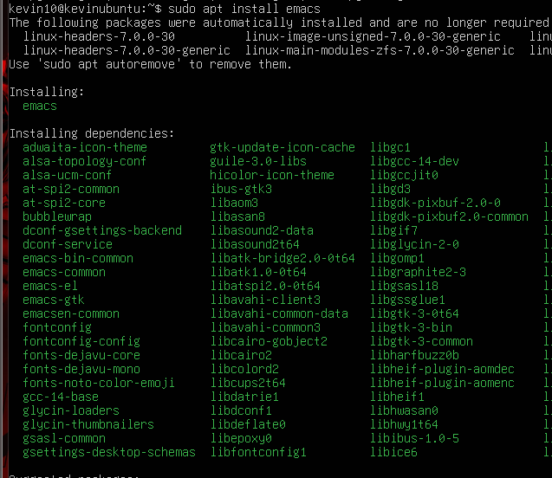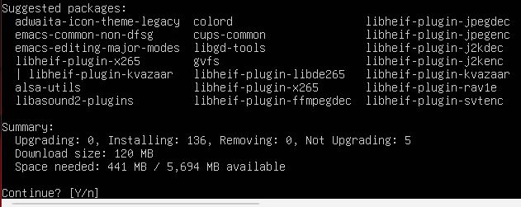
We press “y” for done with the installation of the program.

Installing Fail2Ban
Fail2Ban is a type of prevention software framework that protects our computer server from brute-force attacks.
The command for this is sudo apt install fail2ban
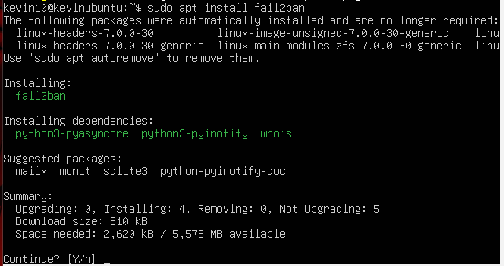
Here we press “y” for install the update.
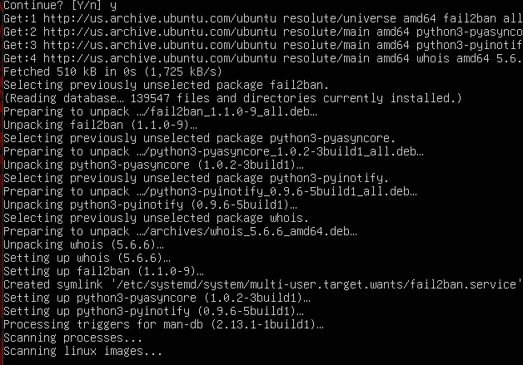
Now the update is done.
Installing Cowsay
What is cowsay? Is a program that generates ASCII art pictures of a cow with a message.
The command is sudo apt install cowsay
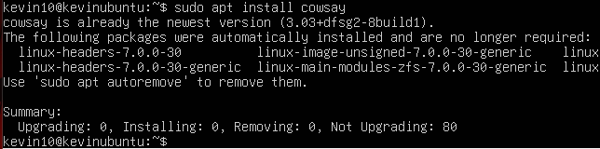
Now the update is installed.

Installing lolcat
Lolcat: is a utility for Linux, BSD and OSX which concatenates like cat command and adds rainbow coloring to it.
The command is sudo apt install lolcat
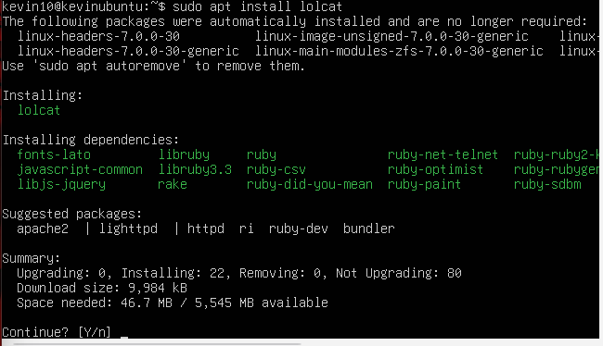
Now we press “y” for done with the update of the system.
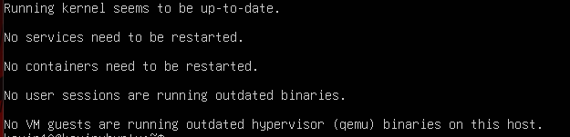
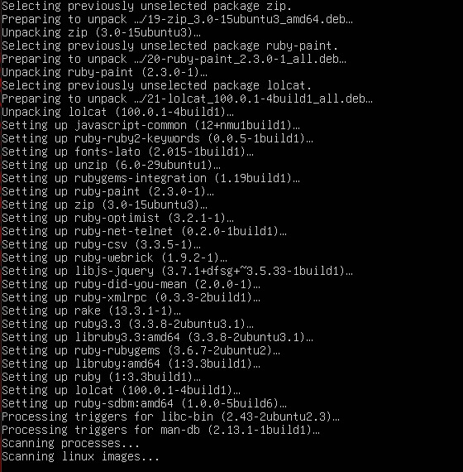

Installing Vim
Vim: as we know VI is the standard text editor used in Linux, Vim in this case is a new version that includes visual mode, mouse support and new editing commands.
Type vim in the command line to see if the update is already there.
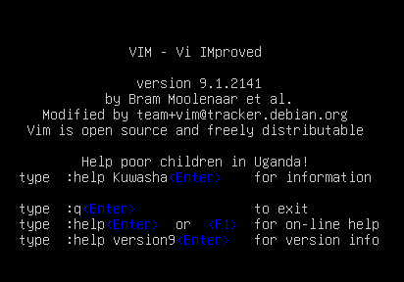
In my case I already have it and I don’t need to install the update again.
If you don’t have it, you can run the command sudo apt install vim.
Now with apt-file allows us to search for files in our available repositories.
Something important, apt-file is not installed by default, we can run the following the next command sudo apt install apt-file
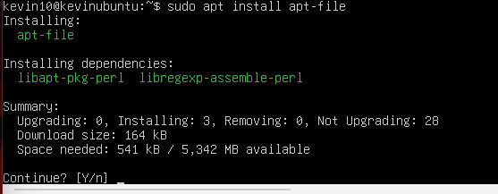
Here we type “y” to process with the installation.
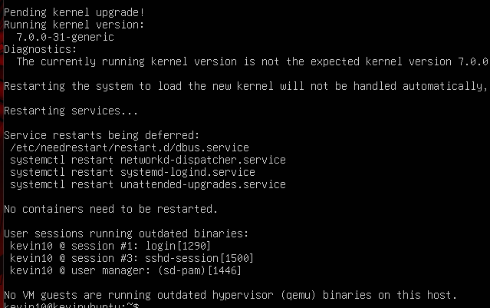
If for some reason you find a error running the command is because the apt-file need to be new so we need to run the command sudo apt-get update or in my case sudo apt-file update
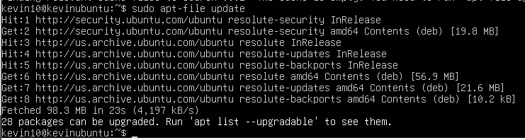
The command is apt-file list “filename”, allow us to search the package and see the location and the content.
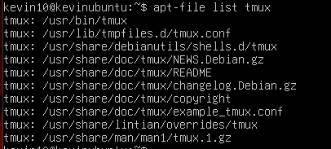
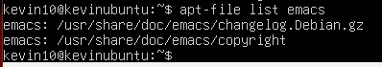
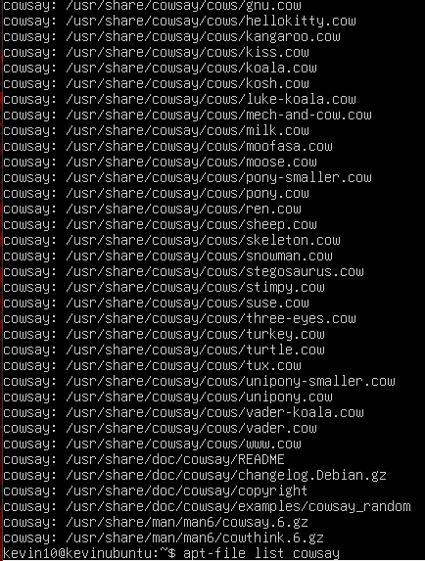

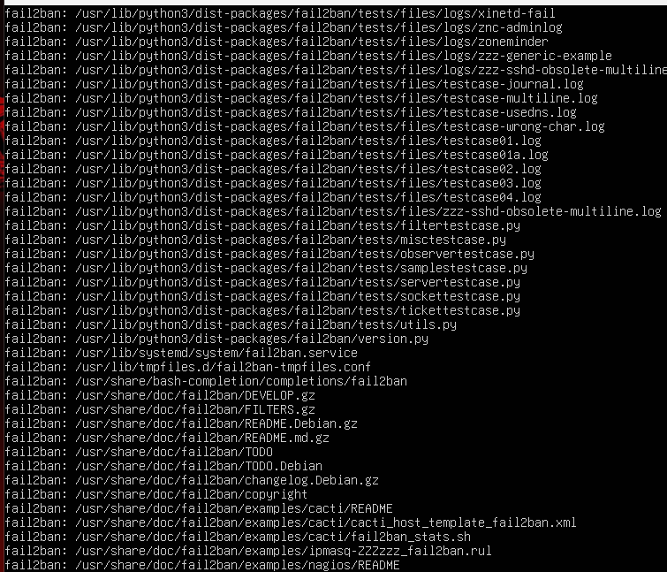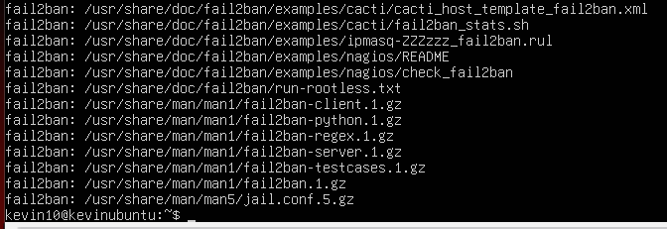

When we want to see what we have installed, we can run the command apt list -installed.
Something important is if you want to use apt list -installed | less so you can pipe through it.
This is the list of packages that we install.
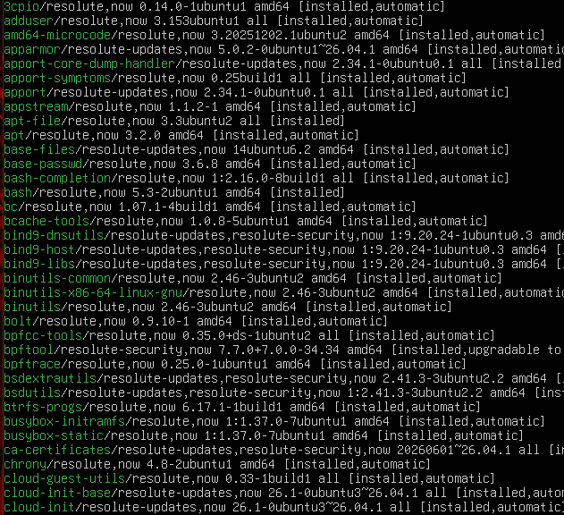
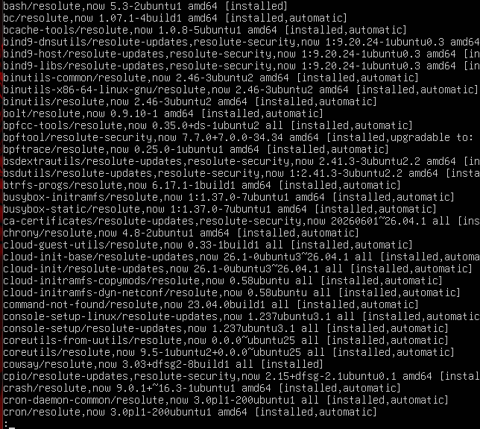

Using the packages that we download and install on our Ubuntu server.
We first start with Tmux, for this we run tmux in the command line, after we press CTRL + B and press (“) for horizontal view, and press % for vertical view.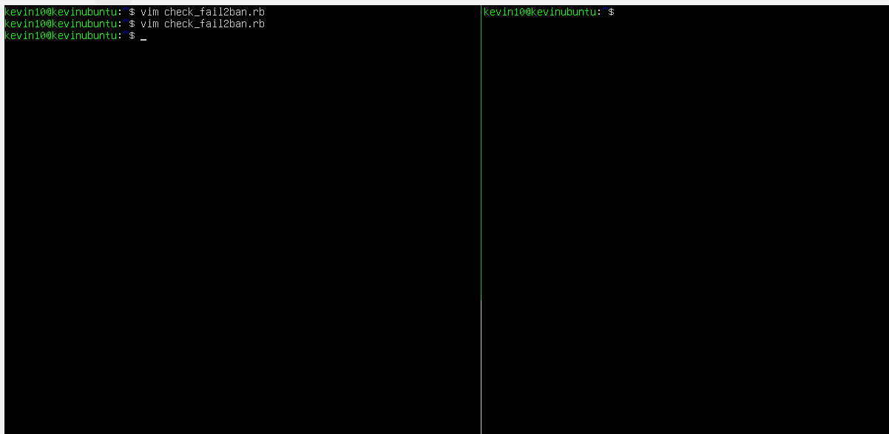
Now we are going to create a script that simulates the fails of people trying to access, for this we run the command vim check_fail2ban.rb, and then press I for insert the text, after doing this code press ESC and write: wq for save the changes.
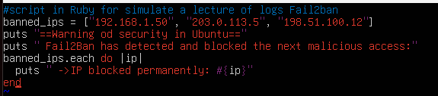
Now we are going to use EMACS to modify the script and add a line, for this we use the code emacs -nw check_fail2ban.rb
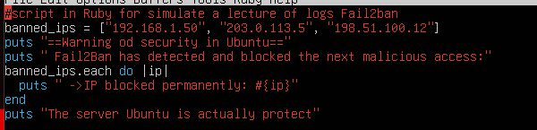
For save these changes and exist of emacs, we press CTRL + X, CTRL + S, CTRL + X, CTRL + C.
Now in the other panel of our Tmux interface we press CTRL + B and then press arrow right.
We want to show our script using cowsay and lolcat, for this the command is ruby check_fail2ban.rb | cowsay | lolcat


